DBS301 DE Lab 2 Section: D Prof : Nebojsa Conkic
Muhammad Shaher Yar Ahmed ID: 126330166

1. Query:
select employee_id, last_name, salary
from employees
where salary between 5000 and 9000
order by salary desc, last_name asc;
Output:

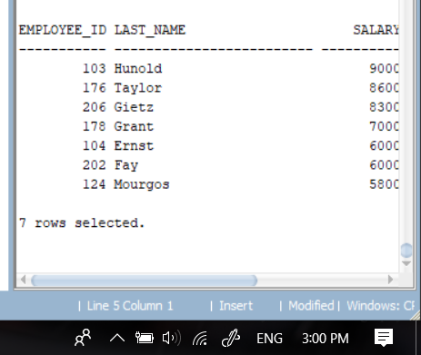

2. Query
select employee_id, last_name, salary
from employees
where salary between 5000 and 9000
and (job_id = 'IT_PROG' or job_id = 'ST_CLERK')
order by salary desc, last_name asc;
Output:
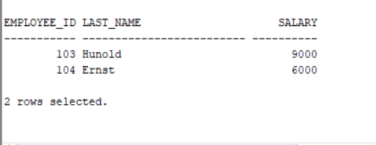

3.Query: select employee_id, last_name, salary
from employees
where salary not between 5000 and 9000
and (job_id = 'IT_PROG' or job_id = 'ST_CLERK')
order by salary desc, last_name asc;
Output:
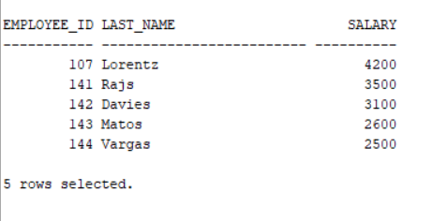

4. Query:
select last_name, hire_date, salary
from employees
where hire_date <= '95-12-31'
order by hire_date;

Output:
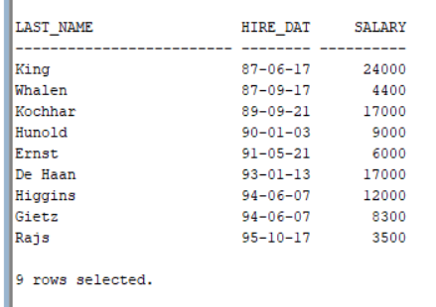

5. Query:
select last_name, hire_date, salary, DEPARTMENT_ID
from employees
where hire_date <= '95-12-31'
and salary < 7500
order by department_id, salary desc;
Output:
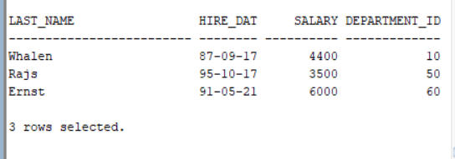
6. Query
select job_id as "Job Title" , first_name || ' ' || last_name as "Full Name"
from employees
where first_name like '%C%' or first_name like '%c%';

Output:
